ORFF NOVA SCOTIA PRESENTS

Orff Level I & II
Halifax Regional Centre for Education
33 Spectacle Lake Drive,
Dartmouth, NS
August 10 - 21, 2020

Endorsed by Carl Orff Canada

This two-week intensive course in the principles and techniques of Carl Orff’s Music for Children leads to Orff Specialist certification. The Orff philosophy of music education is an internationally recognized approach to teaching music in schools or group classes. In this course, teachers learn to foster student performance skills, literacy, and creativity through carefully sequenced musical experiences using songs, games, rhythms, poems, dances, and stories from around the world. Participants receive training in recorder playing, choral techniques, movement, percussion instrument technique, and pedagogy.

INSTRUCTORS:
Level I - Basic Orff – Jenny Trites
Level II - Basic Orff – James Jackson
Additional Instructors – Nancy Tucker & Charlotte Myers

COURSE FEES IF PAID BEFORE June 1, 2020
$700 + *$25 Registration fee for COC members
$725 + *$25 Registration fee for Non-members

COURSE FEES IF PAID AFTER June 1, 2020
$725 + *$25 Registration fee for COC members
$750 + *$25 Registration fee for Non-members

NOTE: The non-refundable Registration fee of $25 must be paid upon registration.

Fees may be paid via PayPal or e-transfer at
http://www.orffnovascotia.com/nova-scotia-levels-courses.html

Course is dependent on numbers. Please apply early to ensure a space in the class. Course is 10 full days Monday – Friday.
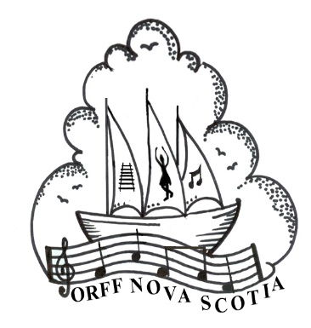

Orff Level I & II
Halifax Regional Centre for Education
33 Spectacle Lake Drive,
Dartmouth, NS
August 10 - 21, 2020

Registration for: Orff Level I or Orff Level II

Student Information:

First Name: Last Name:

Mailing Address: City:

Province: Country: Postal Code:

Email: Home Phone: Cell:

COURSE FEES PAID IN FULL BEFORE June 1, 2020
$700 + *$25 Registration fee for COC members
$725 + *$25 Registration fee for Non-members

COURSE FEES PAID AFTER June 1, 2020
$725 + *$25 Registration fee for COC members
$750 + *$25 Registration fee for Non-members

PLEASE NOTE:
- Text books are not included in the price. Further information to follow after application is received.
- *The registration fee of $25 is due upon registration and is non-refundable.

Fees may be paid via PayPal or e-transfer.
All information can be found at
http://www.orffnovascotia.com/nova-scotia-levels-courses.html

Email completed form to Course Director James Jackson at jacksoj@nspes.ca

