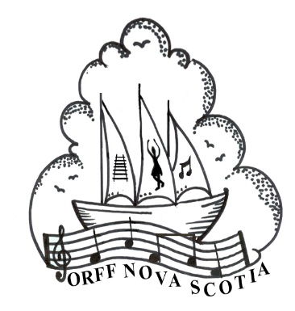**Orff Nova Scotia**

# “Music from Five Continents”

with Doug Goodkin

**I will be attending the:**

Tuesday morning workshop (July 2nd, 2019)

Full week course (July 2nd-6th, 2019) 

First Name:      Last Name:

Mailing Address:       City:

Province:       Country:       Postal Code:

Email:       Phone Number:

Orff Course Level or Experience:

**Fees and Payments:**

COURSE FEES **PAID IN FULL** BEFORE JUNE 1ST:

**Tuesday Morning:** $60

**Full Course:** $450 for COC members/$475 for non-members

**Fees may be paid via PayPal or e-transfer at:**[**http://www.orffnovascotia.com/registration.html**](http://www.orffnovascotia.com/registration.html)

**Fees must be paid by June 1st, 2019 to ensure your space in the course.**

**Please e-mail your completed form to Jennifer Smeltzer, jennifer_smeltzer@hotmail.com**