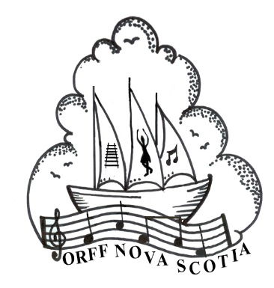
ORFF NOVA SCOTIA

Orff Level I
Oxford School

6364 North Street

Halifax, Nova Scotia

July 8th- July 19th, 2024

Endorsed by Carl Orff Canada

This two-week intensive course in the principles and techniques of Carl Orff’s Music for Children leads to Orff Specialist certification. The Orff philosophy of music education is an internationally recognized approach to teaching music in schools or group classes. In this course, teachers learn to foster student performance skills, literacy, and creativity through carefully sequenced musical experiences using songs, games, rhythms, poems, dances, and stories from around the world. Participants receive training in recorder playing, choral techniques, movement, percussion instrument technique, and pedagogy.

COURSE FEES PAID BEFORE May 31st, 2024
$750 for COC members
$800 for Non-members

COURSE FEES IF PAID STARTING June 1, 2024
$800 for COC members
$850 for Non-members

Course is 10 full days Monday – Friday.

Orff Level I
Fairview Heights Elementary School

210 Coronation Avenue

Halifax, Nova Scotia

July 8th – 19th, 2024

Student Information:

First Name: Last Name:

Mailing Address: City:

Province: Country: Postal Code:

Email: Phone:

Course fees must be paid in full by the start date of the course. Fees will be refunded in full if the courses are not able to move forward. Textbooks are not included in the price. Further information will follow after registration is complete.

Fees may be paid via PayPal or e-transfer.
All information can be found at
http://www.orffnovascotia.com/nova-scotia-registration.html

Please e-mail your completed form to Jennifer Cleveland, ONS President,
at orffnovascotia@gmail.com.
Please indicate how your fees will be paid in the body of the e-mail.

